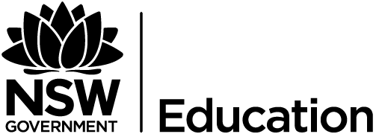

Nationally Consistent Collection of Data on School Students with Disability
Notification for Parents and Carers
All Government and non-Government schools across Australia are required to participate annually in the Nationally Consistent Collection of Data on School Students with Disability (NCCD).
All Australian schools will collect data on their students who are receiving adjustments to meet additional learning and support needs in accordance with their obligations under the Disability Discrimination Act 1992 and Disability Standards for Education 2005. This data will be provided to the Australian Government to assist in the development of a consistent, national picture of the education needs of students with disability.
The data provided to the Australian Government by the NSW Department of Education and Communities is provided in such a way that it cannot be used to identify any individual student or school.
General information about the national data collection can be found on the Australian Government Department of Education and Training website at http://education.gov.au/fact-sheets-nationally-consistent-collection-data-school-students-disability.
Privacy Protection
The NSW Department of Education and Communities follows the requirements of the Privacy and Personal Information Protection Act 1998 and the Health Records and Information Privacy Act 2002. Schools will collect, record, store and use data about individual students in line with these requirements. Data security and protection is a priority and students’ personal details will be kept confidential.
Under Clause 52 of the Commonwealth Australian Education Regulation 2013, data collected by the NSW Department of Education and Communities for the NCCD must be provided to the Australian Government Department of Education and Training. This includes the number of students at each level of education, the number in each category of disability and the number at each level of adjustment. The information is provided to the Commonwealth as a series of number sets that cannot be used to identify any individual student or school.
The Australian Government Department of Education and Training follows the requirements of the Commonwealth Privacy Act 1988 when handling any data provided by NSW Department of Education and Communities in connection with the national data collection. A privacy notice has been developed to by the Australian Government to provide students, parents and carers with important privacy information in relation to the data collection. This notice is available on the department’s website at http://education.gov.au/notices
If you have any questions about the data collection please do not hesitate to contact [INSERT SCHOOL CONTACT]

