Harmony Day 2011 at Doonside Public School
Harmony Day is celebrated each year in Australia on 21st March. The message for ‘Harmony Day’ is “EVERYONE BELONGS”. All Australians are welcome to this country regardless of their background. It is a time to reflect on where Australia has come from, and also recognise the traditional owners of this land. It is about celebrating all the different cultures that make Australia a great place to live.

At Doonside Public School we are celebrating Harmony Day with a variety of activities.
- Classroom focus will be on respecting and including others.
- Each class will read a book and participate in activities from other countries.
- Our first Books in Homes Assembly for 2011 will be held in the afternoon at 2.15.
- Students will listen to the finalists for each Primary Year in the Multicultural Public Speaking Competition. These students will later compete in the Western Sydney Competition.
- Students and Teachers may dress in costumes and national dress from other countries or in Orange Mufti clothes. (Orange is the Harmony colour)
- Please make a gold coin donation for wearing mufti - this will be used to support the Stage One excursion.
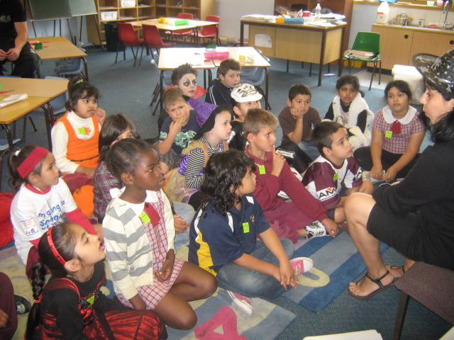

Is your child a little late for school?
From Monday all children who are late for school will need to come to the office to get a late pass.

We now have a different system for recording school attendance which requires late passes as well as early leaver passes to be issued through the office.

Your assistance with this change in routine would be greatly appreciated.

Head lice
We have had some instances reported in various classes of children with head lice. Please check your child’s hair and treat appropriately.

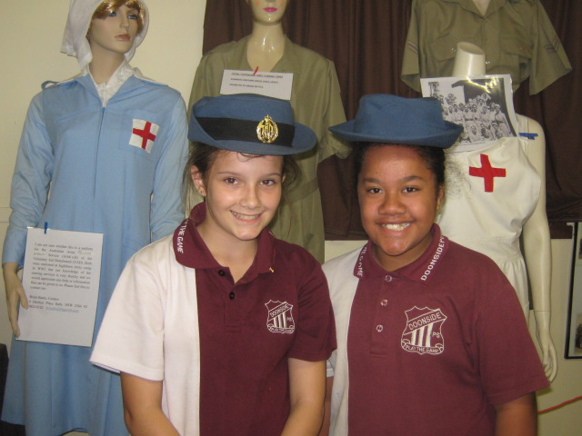

Some of our senior students
visited Bardier Barracks.
What a great insight into military life.

Error.... Oops - sorry
Please note that in our last newsletter it was advised that the students return for Term 2 on 27th April. This is incorrect and students return 28th April.
********************************************
Mark it in your Diary
21/3/11 Harmony Day
2.15pm.m Books In Homes
Assembly Term 1
25/3/11 No CANTEEN today
26/3/11 Election Day – Don’t forget to vote.
28/3/11 Cross Country
8/4/11 Last day Term 1
25/4/11 Anzac Day
27/4/11 Staff Development Day
28/4/11 Students return Term 2

News from our wonderful Canteen Committee
The 2011 P & C and Canteen Committees have been elected.

President: Maureen Coleman
V. Pres: Sarah Muir
Secretary: Jodie Robertson
Treasurer: Joanne Kay

Canteen Manager: Joanne Kay
Asst Manager: Bobbie Wilkinson.

Congratulations on your appointment to these positions.

We are sorry but there is a NO CREDIT policy at the canteen. Please do not ask as refusal often offends.
URGENT NOTICE....URGENT NOTICE
There will be no canteen on Friday 25th March
Please ensure your child has recess, lunch and any drinks they may require.

Easter Raffle – Tickets will shortly be sent out for our Easter raffle.
Tickets will be $1.00 each or 3 for $2.00 and will be drawn prior to the end of this term.

Mothers’ Day is also quickly approaching and the P & C will be holding a stall and also running a Mothers’ Day raffle. These tickets will also be distributed shortly. Don’t miss your chance to win some great prizes – Your have to be in it to win it!

Library
The Books In Homes Assembly for Term 1 will take place on Monday 21st March at 2.15 p.m.

We thank Main Freight for their continued support of this program, without which our children would not receive these free books.

Uniforms
Uniform price list:
Dresses $34.00
Skorts $15.00
Polo Shirts (Size 4 – 16) $18.00
(Adult Size S - XXL) $22.00
Unisex shorts (Size 4 – 16) $15.00
(Adult Size S – XXL) $18.00
Microfibre Jacket $35.50
Microfibre Trackpants $24.50
Hoodies $24.00
Hats $ 8.00
Preschool
Shirts $12.00
Hats $10.00

We have ordered larger sized polo shirts and shorts but to date have not received stock as they needed to be especially manufactured. We will advise as soon as they are received. Thank you for your patience.
***********************
Best Wishes to Mr Tony O’Neill who has been the General Assistant at Doonside Public School for a number of years. He is retiring next Friday, 25th March and we thank him for his contribution to our school and wish him well in his retirement.

